Name:_______________________________ Period: ______ Date: _____/_____/_____

IP 670

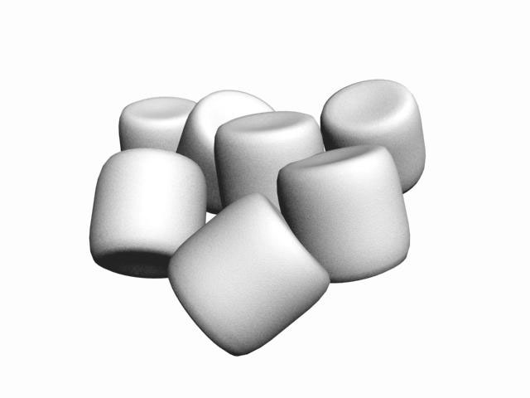The Marshmallow Design Challenge

**Goal**:

The goal of your design team is to build the TALLEST, FREESTANDING structure measured from the tabletop surface to the top of the marshmallow.

**Materials**:

* 20 sticks of spaghetti
* 1 meter of masking tape
* 1 meter of string
* 1 marshmallow

**Rules**:

1. The entire marshmallow must be on **TOP**! Cutting or eating part of the marshmallow disqualifies the team.
2. Use as MUCH or as LITTLE of the materials provided. Feel free to break-up the spaghetti, cut up the tape and strings to create new structures.
3. Time Limit: 18 minutes! The team cannot hold onto the structure when the time runs out. Those touching or supporting the structure at the end of the exercise will be **disqualified**.

Note: The final structure must be a freestanding structure. Therefore, it cannot be suspended from a higher structure: like a chair, ceiling, or chandelier.

Name:_______________________________ Period: ______ Date: _____/_____/_____

IP 670

**Reflection: Marshmallow Challenge**

1. Briefly outline the engineering design process you used to in the Marshmallow Design Challenge (diagram, drawings, written steps, etc).
2. Why do we need to learn about science?
3. Why do we need to learn about engineering?