Purpose
- See that experimental probability approaches theoretical probability when a sufficient number of experiments are conducted.
- Determine the quantity of each color of block in the container.
- Use iSENSE to visualize and explore this effect.

Materials
- Container with 12 blocks; yellow, red, blue
- Computer, tablet, or iPad with internet connection
- Interactive website – www.isenseproject.org
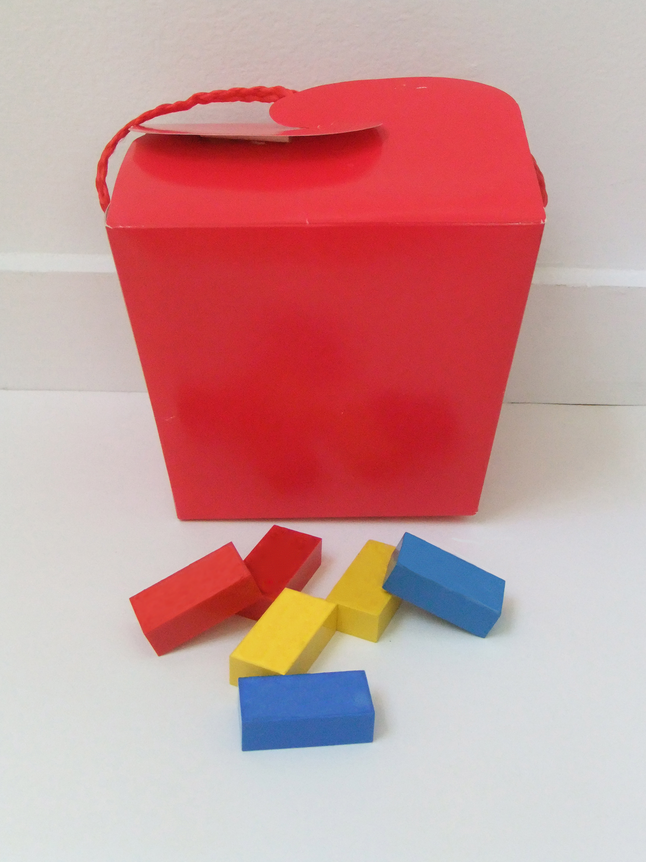
Method
- Divide into groups of 2 and gather materials.

- Without looking in the container, student 1, select one block from the container and without replacing it, select another block from the container. Record the draws with one tally mark on Table 1, for example yellow then blue, place tally mark under “yb”. Replace the blocks into the container.

- Without looking in the container, student 2, select one block from the container and without replacing it, select another block from the container. Record the draws with one tally mark on Table 1. Replace the blocks into the container.

- Students 1 and 2 take turns repeating steps 2 and 3 until each has tallied 10 outcomes.

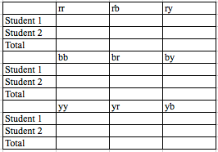
Table 1
- Enter your Totals into iSENSE
- Go to www.isenseproject.org
- Login as directed by your teacher
- Click on Projects
- Click on Block Probability
- Click on Data, Manual Entry
- Enter the data set name i.e.: Class period - T3 FirstName & FirstName
- Click on Save

iSENSE Analysis
- Select your data set and click Visualize.
- Verify correct input of your data at Table.
- Use the Bar Chart to examine your data.
- Add data contributed by other participants and visualize using Bar Chart, Histogram.
- Save any visualization that you find particularly interesting.

Discussion Questions
      - Is this an independent or dependent event?
      - What is the theoretical probability that you choose a blue block and then a yellow block?
      - How does this theoretical probability differ from your experimental probability?
      - If we examine the experimental data from the entire class, does the experimental probability change? How?
      - What questions might you investigate if you were to repeat this experiment?

