Purpose
- Determine the mass, volume, and density of objects made from various materials.
- Compare density across materials.
- Use iSENSE to visualize and explore object properties and measurement variability.

Materials
- Small objects to measure
- Graduated cylinder (preferably in mL)
- Scale (preferably in grams)
- Water source and extra container
- Computer or tablet with internet connection

Method
- Divide into groups and gather materials (multiple items of the same type can be measured simultaneously — e.g. your “object” could be “4 washers”).
- Select an object and describe it in Table 1 (object type).
- Measure and record the object mass.
- Measure the volume of your object.
  - Fill the graduated cylinder with enough water to submerge your object without overflowing. Note the original volume on scratch paper. (Hint: Fill to a round number of mL to simplify calculations.)
  - Carefully submerge the object and tap the graduated cylinder to remove bubbles.
  - Note the new volume. Record the volume of your object (new volume minus original volume) in Table 1.
- Calculate the density by dividing mass by volume. Record density in Table 1.

Mass  (g) | Volume (mL) | Density (g/mL) | Object Type
Table 1

- Repeat steps 2–5 for other objects.
- Enter your data from Table 1 into iSENSE.
- Go to www.isenseproject.org
- Login as directed by your teacher.
- Click on Project and search for Density of Objects or 709.
- Click on Manual Entry under Contribute Data.
- Enter a data set name (e.g. partners’ first names).
- Enter data. Use “Add Row” as necessary. Then click Save.

iSENSE Analysis
- Verify correct input of your data in Table.
- Use the Scatter plot with volume on the X axis and mass on the Y axis.
- Group the data by Object Type and examine the scatter plots for different objects.
- Enable data for one Object Type only, and draw a linear Best Fit Line.
- Mouse over the line to see the slope.
- Explore your data together with others’ data.
- Save any visualization that you find interesting.

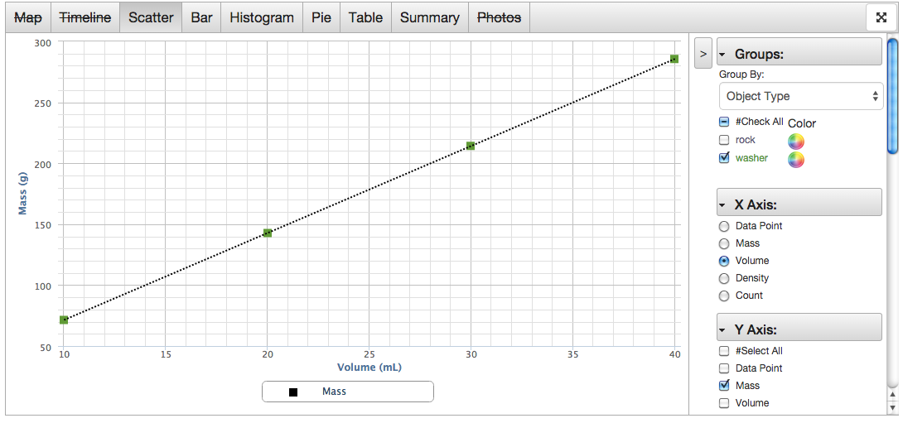

Discussion Questions
      - How do the densities of different materials compare to each other?
      - How does the slope of the line from Analysis Step 5 relate to the density of an object?
      - What questions might you investigate if you were to repeat this experiment?

