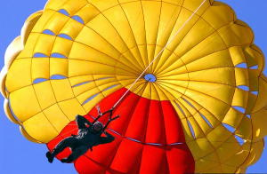
Parachutes
by Chris Woodford.
Last updated: October 10, 2014.
You're screaming through the sky, safely tucked up in the cockpit of a jet fighter, when there's a sudden loud bang and the engine judders to a halt. Well that's just great, isn't it? Here you are zooming along at maybe 2000 km/h (1200mph), several kilometers/miles above the ground and your plane has chosen this exact moment to break down! What do you do? Eject as soon as you possibly can, wait for the plane to fly clear, and then hit your parachute. With luck, you glide safely to the ground and live to fly another day. When it comes to saving lives, parachutes are among the simplest and most effective of inventions. How exactly do they work? Let's take a closer look!
Photo: Ordinary parachutes are dome-shaped and, with their dangling suspension lines, look a bit like jellyfish as they fall. Note the vent holes that allow air to escape: they help to prevent the parachute from rocking about as it falls and provide very basic steering (though nothing like as sophisticated as on ram-air parachutes). Photo by Chris Desmond courtesy of US Navy.

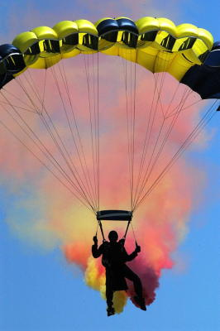
How does a parachute work in theory?
Photo: Sophisticated ram-air parachutes like this have a number of cells that inflate (fill with air) so they form a curved airfoil wing. They are much more steerable and controllable than dome-shaped parachutes. Photo by Shannon K. Cassidy courtesy of US Navy.
Throw a ball up in the air and, sooner or later, it always falls back to the ground. That's because Earth pulls everything toward it with a force called gravity. You've probably learned in school that the strength of Earth's gravity is roughly the same all over the world (it does vary a little bit, but not that much) and that if you drop a heavy stone and a light feather from the top of a skyscraper, gravity pulls them toward the ground at exactly the same rate.
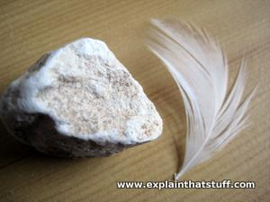
If there were no air, the feather and the stone would hit the ground at the same time. In practice, the stone reaches the ground much faster, not because it weighs more but because the feather fans out and catches in the air as it falls. Air resistance (also called drag) slows it down.
Photo: It's hard to believe, but if you drop a feather and a stone side by side in a vacuum (with no air—and no air resistance) they will reach the ground at exactly the same time!

What causes air resistance?
Just because the air's invisible, doesn't mean it's not there. Earth's atmosphere is packed full of gas molecules, so if you want to move through air—by walking, in a car, in a plane, or dangling from a parachute—you have to push them out of the way. We only really notice this when we're moving at speed.
Air resistance is a bit like the way water pushes against your body when you're in a swimming pool—except that air is invisible! If you jump off a diving board or do a belly flop, the awkward shape of your body will create a a lot of resistance and bring you rapidly to a halt when you crash into the water. But if you make a sharp pointed shape with your arms and dive in gracefully, your body will part the water cleanly and you'll continue to move quickly as you enter it. When you jump or belly flop, your body slows down quickly because the water can't get out of the way fast enough. When you dive, you part the water smoothly in front of you so your body can glide through it quickly. With parachutes, it's the slowing-down effect that we want.
If you fall from a plane without a parachute, your relatively compact body zooms through the air like a stone; open your parachute and you create more air resistance, drifting to the ground more slowly and safely—much more like a feather. Simply speaking, then, a parachute works by increasing your air resistance as you fall.

Terminal velocity
When a force pulls on something, it makes that object move more quickly, causing it to gain speed. In other words, it causes the object to accelerate. Like any other force, gravity makes falling objects accelerate—but only up to a point.
If you jump off a skyscraper, your body ought to speed up by 10 meters per second (32ft per second) every single second you're falling. We call that an acceleration of 10 meters per second per second (or 10 meters per second squared, for short, and write it like this: 10m/s/s or 10m/s²). If you were high enough off the ground, then after about a minute and a half (let's say 100 seconds), you'd theoretically be falling at about 1000 meters per second (3600km/h or 2200 mph), which is about as fast as the fastest jet fighters have ever flown!
In practice, that simply doesn't happen. After about five seconds, you reach a speed where the force of air resistance (pushing you upward) increases so much that it balances the force of gravity (pulling you downward). At that point, there is no net acceleration and you keep on falling at a steady speed called your terminal velocity. Unfortunately, the terminal velocity for a falling person (with arms stretched out in the classic freefall position) is about 55 meters per second (200km/h or 125 mph), which is still plenty fast enough to kill you—especially if you're falling from a plane!
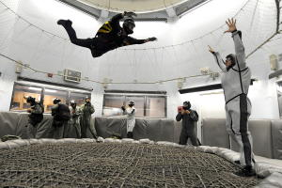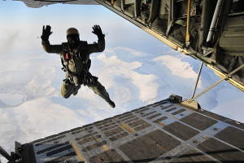
Photo: Left: Freefall in theory: In this training exercise, the skydiver is practicing freefall by floating over a huge horizontally mounted air fan. The force of the air pushing upward is exactly equal to the diver's weight pulling him downward so he floats in mid-air. Photo by Gary L. Johnson courtesy of US Navy. Right: Freefall in practice: In reality, it's not the air that moves past you—you move through the air—but the physics is still the same: once you reach terminal velocity, the force of the air on your body pushing you upward exactly equals the force of gravity pulling you down. Photo by Ashley Myers courtesy of US Navy.

How much does a parachute slow you down?
Feathers fall more slowly than stones because their terminal velocity is lower. So another way of understanding how a parachute works is to realize that it dramatically lowers your terminal velocity by increasing your air resistance as you fall. It does that by opening out behind you and creating a large surface area of material with a huge amount of drag. Parachutes are designed to reduce your terminal velocity by about 90 percent so you hit the ground at a relatively low speed of maybe 5–6 meters per second (roughly 20 km/h or 12 mph)—ideally, so you can land on your feet and walk away unharmed.

How does a parachute work in practice?
Skydivers make parachuting look easy, but it's all a bit more tricky in practice! What you're trying to achieve is to get a large piece of super-strong material opening out above and behind you in a perfectly uniform way when you've just jumped from a plane screaming along maybe ten times faster than a race car! How can you possibly pull something safely behind you under those conditions?
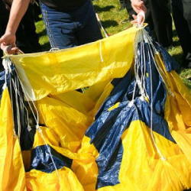
Parachutes are actually three chutes in one, packed into a single backpack called the container. There's a mainparachute, a reserve parachute (in case the main one fails), and a tiny little chute at the bottom of the container, called the pilot chute, that helps the main chute to open. Once you're clear of the plane, you trigger the pilot chute (either by pulling on a ripcord or simply by throwing the pilot chute into the air). It rapidly opens up behind you, creating enough force to tug the main chute from the container. The main chute has to be carefully packed so the ropes that connect it to your harness (known as suspension lines) open correctly and straighten out behind you. The main chute is designed to open in a delayed way so your body isn't braked and jerked too suddenly and sharply. That's safer and more comfortable for you and it also reduces the risk of the parachute ripping or tearing.
The force on a parachute is considerable, so it has to be made from really strong materials. Originally, parachutes were made from canvas or silk, but inexpensive, lightweight, synthetic materials such as nylon and Kevlar® (a chemical relative of nylon) are now generally used instead.
Photo: Parachutes are made from strong lightweight nylon and have to be packed very carefully if they're to open correctly when they're deployed. Photo by Gary Ward courtesy of US Navy.

What a drag!
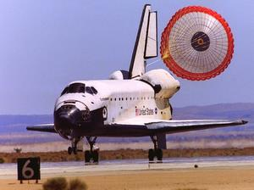
Using a parachute to bring a person safely to the ground from a plane is one thing. But what if you had to bring an entire plane to rest the same way? That was the challenge facing NASA every time the Space Shuttle (the reusable space plane, now-retired) came back to Earth.
During its launch phase, the Shuttle had a powerful main engine and rocket boosters to power it into space. But when it came back again, it was nothing but a glider, drifting through the air and counting on its stubby wings to carry it home.
Once it was safely back inside Earth's atmosphere, the Shuttle hit its 4.5km (2.8mile) long landing strip at about 350km/h (220mph)—rather faster than a typical jet airplane (which lands at speeds more like 240km/h or 150mph). When the wheels were on the ground, the crew applied the brakes to bring the craft safely to a halt, but they also used a horizontal parachute called a drag chute to help. It was about 12m (40ft) across and helped to cut the Shuttle's speed by about 75 percent before it was jettisoned.
Photo: The Space Shuttle Endeavour, coming in to land on June 19, 2002. Photo courtesy of NASA Armstrong Flight Research Center.

