**Making Sense of Density Name: ____________________________**

Problem: Does the density of a material vary with volume?

Materials:

balance water paper towels metric ruler graduated cylinder, 100-mL wooden stick, about 6 cm long ball of modelling clay, about 5 cm wide crayon with paper removed

Procedure:

*Before beginning, read through the procedures and create a date table in which to record your data.*

1. Use a balance to find the mass of the wooden stick. Record the mass in a data table.

2. Add enough water to a graduated cylinder so that the stick can be completely submerged. Measure the initial

volume of the water.

3. Place the stick in a graduated cylinder. Measure the new volume of water.

4. The volume of the stick is the difference between the water levels in Steps 2 and 3. Calculate this volume

and record it.

6. Thoroughly dry the stick with a paper towel. Then carefully break the stick into two pieces. Repeat Steps 1

through 5 with each of the two pieces.

7. Repeat Steps 1 through 6 using the clay rolled into a rope.

8. Repeat using the crayon.

**Making Sense of Density Name: ____________________________**

Problem: Does the density of a material vary with volume?

Materials:

balance water paper towels metric ruler graduated cylinder, 100-mL wooden stick, about 6 cm long ball of modelling clay, about 5 cm wide crayon with paper removed

Procedure:

*Before beginning, read through the procedures and create a date table in which to record your data.*

1. Use a balance to find the mass of the wooden stick. Record the mass in a data table.

2. Add enough water to a graduated cylinder so that the stick can be completely submerged. Measure the initial

volume of the water.

3. Place the stick in a graduated cylinder. Measure the new volume of water.

4. The volume of the stick is the difference between the water levels in Steps 2 and 3. Calculate this volume

and record it.

6. Thoroughly dry the stick with a paper towel. Then carefully break the stick into two pieces. Repeat Steps 1

through 5 with each of the two pieces.

7. Repeat Steps 1 through 6 using the clay rolled into a rope.

8. Repeat using the crayon.

[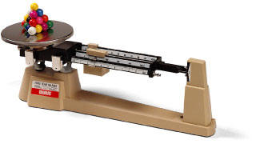](http://www.ebsinstitute.com/Baseball/EBS.crp2df.html)[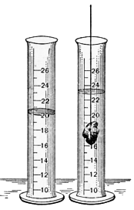](http://askville.amazon.com/archimedis-principal/AnswerViewer.do?requestId=230131)

[](http://askville.amazon.com/archimedis-principal/AnswerViewer.do?requestId=230131)[](http://www.ebsinstitute.com/Baseball/EBS.crp2df.html)