Golden Ratio Lab An investigation of ratios

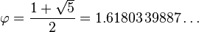

About the Golden Ratio
De Divina Proportione, a three-volume work by Luca Pacioli, was published in 1509. Pacioli, a Franciscan friar, was known mostly as a mathematician, but he was also trained and keenly interested in art. De Divina Proportione explored the mathematics of the golden ratio. Though it is often said that Pacioli advocated the golden ratio's application to yield pleasing, harmonious proportions, Livio points out that the interpretation has been traced to an error in 1799, and that Pacioli actually advocated the Vitruvian system of rational proportions.

The Vitruvian Man is a drawing created by Leonardo da Vinci circa 1490.[1] It is accompanied by notes based on the work of the architect Vitruvius. The drawing, which is in pen and ink on paper, depicts a male figure in two superimposed positions with his arms and legs apart and simultaneously inscribed in a circle and square. The drawing and text are sometimes called the Canon of Proportions or, less often, Proportions of Man. It is stored in Venice, Italy, Gallerie dell'Accademia, Gabinetto dei disegni e stampe, as catalog number 228, and, like most works on paper, is displayed only occasionally.

Since the 20th century, the golden ratio has been represented by the Greek letter Φ or φ (phi, after Phidias, a sculptor who is said to have employed it) or less commonly by τ (tau, the first letter of the ancient Greek root τομή—meaning cut).

ISense is a visualization software we will use to visualize these data. It was developed at UMass Lowell Computer Science department with Dr. Fred Martin and James Dalphond.
http://isenseproject.org
Login: ElaineMistretta
Password: Rockport

Take the following measurements
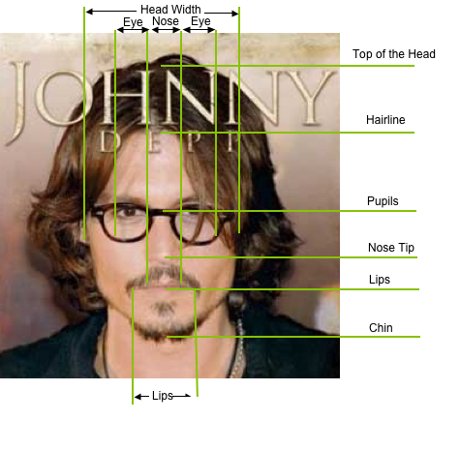
- The length of the face y = _______
- The width of the face x = _______
Ratio: length / width y / x = _______
Reciprocal: width / length x / y = _______

- Top of the forehead to between the eyes. a = _______
- Between the eyes to the bottom of the nose. b = _______
- Bottom of the nose to bottom of the chin. c = _______
- Distance between pupils p = _______

Ratios: a/b = _______ How many can be investigated?
Reciprocals: b/a = _______

- Length of the ear e = _______
- Length of the nose n = _______

Ratios: e/n = _______
Reciprocals: n/e = _______

- Width of the eye w = _______
- Distance between the eyes d = _______
Ratio and reciprocal: w/d = _______ d/w = _______

- Distance to the inside corners of the eyes i = _______
- Distance to the outside corners of the eyes o = _______
Ratio and reciprocal: i/o = _______ o/i = _______

