Finding Your Heart Rate.

Measuring Your Heart Rate
- Use the first two fingers of one hand to feel your radial pulse on the opposite wrist, as shown in Figure 2. You will find it on the "thumb side" of your wrist, just below the base of your hand. Practice finding your pulse until you can do it quickly. Note: Do not use your thumb, because it has its own pulse, which could throw off your count.

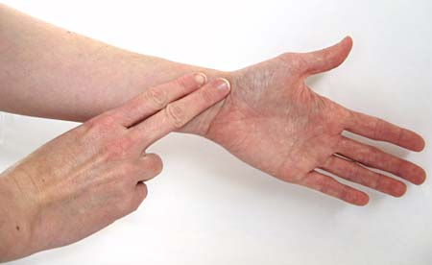
Figure 2. The photo shows how to feel your radial pulse.

- Your heart rate is the number of beats per minute, but you do not have to count for a full minute to get an accurate heart rate. Counting the number of beats in either 10 or 15 seconds is fine. As practice, right now use a clock or timer to time your count, and write down the number of beats you counted in your lab notebook. Then calculate the number of beats per minute (bpm) to get your heart rate. If you counted for ten seconds what do you need to multiply by to get the number of beats per minute? How about if you counted for 15 seconds? That is it!

