Purpose
- Determine the quantity of each color of object in the container.
- See that experimental probability approaches theoretical probability when a sufficient number of experiments are conducted.
- Use iSENSE to visualize and explore this effect.

Materials
- One of two colored bags containing 12 objects: yellow, red, blue
- Computer or tablet with internet connection
- Interactive website – isenseproject.org

Method
- Work in groups of two.
- Without looking in the container, Student 1 selects one object from the container and note its color with a tally mark in Table 1. Place the object back into the container.
- Without looking in the container, Student 2 selects one object from the container and note its color with a tally mark in Table 1. Place the object back into the container.
- Students 1 and 2 take turns repeating steps 2 and 3 until each has tallied six outcomes, for a total of 12 outcomes.

 | Red | Blue | Yellow
Student 1
Student 2
Total
Table 1

- Given that there are 12 objects in the container, calculate how many there are of each color, based only on your experimental probability.

6. Enter your Totals from Table 1 into iSENSE:
- Go to isenseproject.org
- Login as directed by your teacher.
- Click on Project.
- Search for Single Draw with Replacement Probability with Two Distributions or 707.
- Click on Manual Entry under Contribute Data.
- Enter a data set name (e.g. partners’ first names).
- Enter data. Use “Add Row” as necessary. Then click Save.

iSENSE Analysis
- Verify correct input of your data in Table.
- Use the Bar chart to examine your data.
- Add data contributed by other participants and visualize using Bar chart or Histogram.
- Save any visualization that you find particularly interesting.

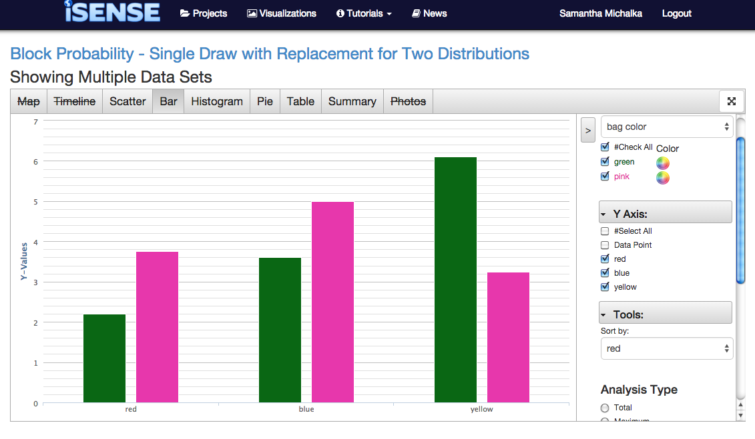

Discussion Questions
      - If we examine the experimental data from the entire class for your bag color, does the experimental probability change? How?
      - What conclusion can you infer given your answers from your calculation in Method Step 5 and Question 1?
      - How do the distributions of objects vary across the two bag colors?
      - What questions might you investigate if you were to repeat this experiment?

